March 16, 2020

Via Electronic Link:

Office of Management and Budget
725 17th Street, NW
Washington, DC 20503

Re: Office of Management and Budget (OMB) Request for Comments on Improving and Reforming Regulatory Enforcement and Adjudication; Docket No. OMB-2019-0006; 85 FR 5483 (January 30, 2020)

Dear Sir/Madam:

On behalf of the American Bar Association’s Judicial Division, I am pleased to submit the attached comments in response to OMB’s request for comments on Improving and Reforming Regulatory Enforcement and Adjudication referenced above.

Please note that these views are being presented only on behalf of the Judicial Division. They have not been approved by the House of Delegates or the Board of Governors of the American Bar Association and should not be construed as representing the policy of the American Bar Association.

If you have any questions after reviewing this report, I will be happy to provide further comments.

Sincerely,

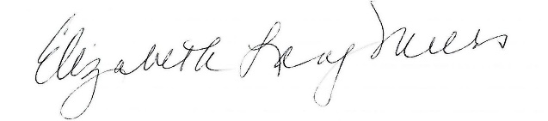

Justice Elizabeth Lang-Miers (Ret.)
Chair, Judicial Division

Attachment

In addition to these comments expressing the Judicial Division's views, the ABA is also submitting a separate, more general comment letter to OMB in response to the Request for Information that expresses the views of the ABA.

