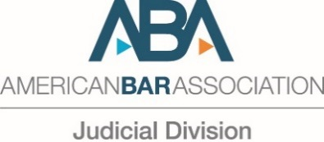
American Bar Association
Judicial Division
321 North Clark Street
Chicago, IL 60654
312-988-5700
www.americanbar.org/jd

March 12, 2020

REQUEST FOR EXPEDITED BLANKET AUTHORITY

SUBJECT: Comments to U.S. Office of Management and Budget Concerning its Request for Comments on Improving and Reforming Regulatory Enforcement and Adjudication, 85 FR 5483 (January 30, 2020)

OBJECTION DEADLINE: Monday, March 16, 2020, 2:00 pm Central Time

PROPOSED SUBMISSION DATE: Monday, March 16, 2020, 3:00 pm Central Time

The Judicial Division of the American Bar Association requests Expedited Blanket Authority to submit the attached comments to the U.S. Office of Management and Budget (OMB) in response to OMB’s request for comments on “Improving and Reforming Regulatory Enforcement and Adjudication,” published in the Federal Register on January 30, 2020. 85 FR 5483. This request is expedited due to the time required to prepare the comments, obtain Council approval, and meet OMB’s March 16 filing deadline.

The views expressed herein are being presented on behalf of the Judicial Division. They have not been approved by the House of Delegates or the Board of Governors of the American Bar Association and, accordingly, should not be construed as representing the position of the Association.

The subject matter is within the primary jurisdiction and expertise of the Judicial Division and is not in conflict with current ABA policy or existing blanket authority statement. The Judicial Division Council voted to approve the comments on March 11, 2020. The National Conference of Federal Trial Judges, the Appellate Judges Conference and the representative of the National Judicial College all abstained.

We are not aware of any material interest in the subject matter of this request on the part of any voting member of the Judicial Division which initiated the request or of the voting members of the Judicial Division Council which approved the request by reason of specific employment or representation of clients. In particular, although some of the Division Conference members of council members who initiated or approved the blanket authority request either represent federal employees or are federal employees themselves, none has been hired or employed by, provided representation to, or received a fee from, a client for any services in connection with the blanket authority request.

In addition to these comments expressing the Judicial Division's views, the ABA is also submitting a separate, more general comment letter to OMB in response to the Request for Information that expresses the views of the ABA.

Sincerely,

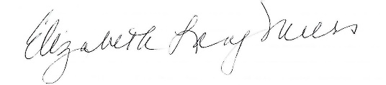

Elizabeth Lang Miers
As Chair, Judicial Division

cc: William R. Bay, Chair, House of Delegates
Mary L. Smith, ABA Secretary
Holly Cook, Associate Executive Director, D.C. Operations
R. Larson Frisby, Associate Director, ABA Governmental Affairs Office
Hilary H. Young, Chair, Section Officers Conference
Alpha M. Brady, Senior Associate Executive Director, Chief Governance Office
Governance and Public Services Group
Janae Leflore, Division Director, Policy Administration
All Section and Division Chairs and Staff Directors

